Cairo University Data Analytics

Faculty of Computers and Artificial Intelligence Winter 2023

Operations Research and Decision Support Department Lab #2

**Lab Objectives**

* Descriptive Statistics
* Charts
* Conditional Formatting
* Filtering & Sorting

**Part 1** **Descriptive Statistics**

We will learn how to use the Analysis Toolpak add-in in Excel to generate descriptive statistics for any given data. For example, you are given the scores of 14 students for an exam. What **measures** can you calculate from this data and what would they tell you.

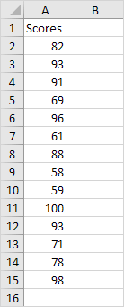

To generate descriptive statistics for these scores, execute the following steps.

1. On the Data tab, in the Analysis group, click Data Analysis.

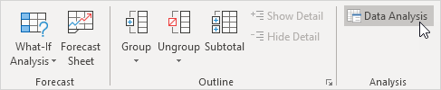

2. Select Descriptive Statistics and click OK.

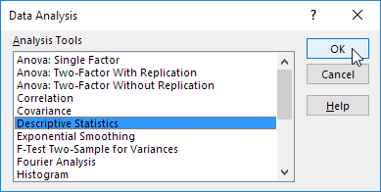

3. Select the range A2:A15 as the Input Range.

4. Select cell C1 as the Output Range.

5. Make sure Summary statistics is checked.

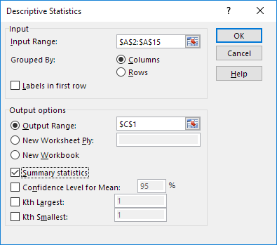

6. Click OK.

Result:

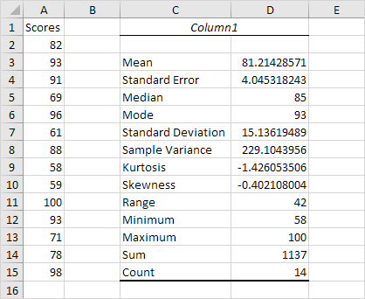

Let’s discuss and reflect on the results together.

Next, how would you **communicate your findings and conclusions** about this data?

**Part 2** **Charts**

1. You work as reporter in a magazine, specialized in cinema and movies. You are writing an article about the movie “Jurassic Park” and how it is still considered as one of the turning points in the history of Sci-Fi and how it is especially popular with teens and adults. You create a survey about the favorite films, and you collect a sample from people with different age groups, you get the results below:

|  |  |  |  |  |
| --- | --- | --- | --- | --- |
| Favorite Films By Age group | | | | |
|  |  |  |  |  |
|  |  | **15 - 25 yrs** | **26 - 40 yrs** | **Over 40's** |
|  |  |  |  |  |
| **Barbarella** |  | 17% | 31% | 18% |
| **Die Hard** |  | 20% | 15% | 1% |
| **Gone with the Wind** |  | 4% | 19% | 41% |
| **Jurassic Park** |  | 34% | 12% | 3% |
| **Speed** |  | 17% | 8% | 11% |
| **Titanic** |  | 8% | 15% | 26% |
|  |  |  |  |  |
| % denotes the percentage of the sample that marked the film as their favorite. | | | |  |

Create a chart to compare the favorite films data for 15-25 year olds only, so that you can include it in your article to emphasize your opinion and show your work in a catchy way.

Be careful not to include any unnecessary blanks rows or columns in your selected data.

1. Given the data below, about the results of Athens Olympics in 2004, how would you summarize the data for graphical presentation? Focus on the top 6 countries.

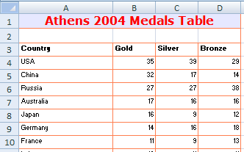

1. You started dieting and exercising for a month, so you kept monitoring your weight (in pounds) every day. What do you think your results are showing, and why? Can you visualize it? (Hint: Try harder next month)

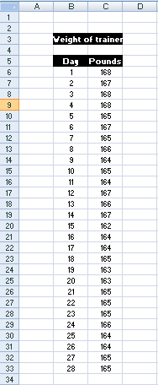

**Part 3** **Conditional Formatting**

Given the following data about Company ABC Part-time Workers Weekly Pay, apply the conditional formatting rules required below, and try to think about the advantage of each one.



**Part 4 Filtering & Sorting**

Given data about fitness classes and their schedules as shown below, perform the following:

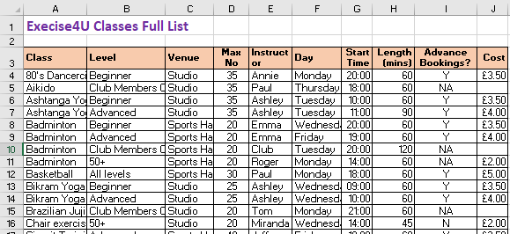

*The top part of the file looks like this pre-sorting/filtering*

1. Sort the table by:
   1. Course level; then
   2. Start time; then
   3. Cost.

The top part of your file should resemble this:

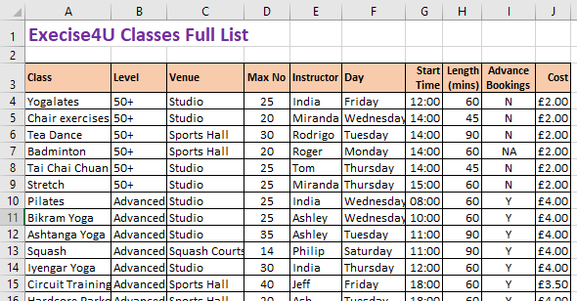

*The table has now been sorted on 3 columns.*

1. Let’s say Debbie has asked for Monday evening off.  Use filtering to show rows where:
   1. The instructor is Debbie; and
   2. The day is Monday; and
   3. The time is after 17:00.

This should find the following classes that you need to find cover for:

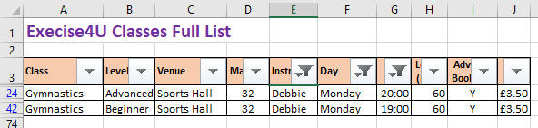

*There are just 2 classes that Debbie has on Monday evenings.*

1. The sports hall floor is being deep cleaned on Wednesday evening at 8pm.  Use filtering to find the classes you need to cancel - that is, where:
   1. The venue is the sports hall; and
   2. The day is Wednesday; and
   3. The time is greater than or equal to 20:00.

This should find the following classes that need to be cancelled:

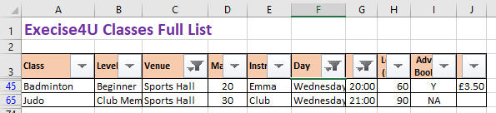

*There are only 2 classes that need to be cancelled.*